The hypotheses is as below:

Adding trust-inducing copy on the email, phone and opt-in fields at checkout will lead to an increase in transactions.

Test run dates: 10/18/19- 10/31/19

Device : Desktop, Mobile

I am further exploring the Users(New and existing) and the Returning Users to see if the test results in increase in transactions or conversions.

Steps:

1. View- Test View
2. Select a date range. pre-event Oct 4th to Oct 17th :post-event- Oct 18th – Oct 31st
3. Segment -Returning Users for Returning users

For each combination of Dimensions and Metrics, I am doing a descriptive analysis and also applying Linear Regression to the data to determine the statistical significance.

A linear regression is say like :

Y ~ aX1 + bX2 + cX3 +ε

The concept of Linear Regression is determining the proportion of variation of the dependent variable (Y), due to independent variable(predictors) X1 or X2 or X3.

P-values and coefficients(a, b or c) in regression analysis work together to tell which relationships in the model are statistically significant and the nature of those relationships.

The coefficients describe the mathematical relationship between each independent variable and the dependent variable. Each regression coefficient is independent of all the other predictors. If ‘a’ is positive, then for every one unit increase in X1, Y increase by ‘a’. On the other hand, if ‘a’ is negative, for every one unit increase in ‘a’, Y decreases by ‘a’ unit.

The null hypothesis of the model is that predictors are insignificant. If P value is <0.05 it means that there is very less probability that the predictor is insignificant, so we reject the Null.

In the following analysis, I am considering p-values to determine the statistical significance for the predictors in the test period.

**Conversions: eCommerce**

**#1. Users. Dimensions**: Device, Browser **Metrics**: Revenue

**Returning Users. Dimensions**: Device, Browser **Metrics**: Revenue

**Figure 1**

In the test period data set, Device does not seem to have any significance on variations in Revenue.

**#2. Users. Dimensions**: Device, Ad-Content **Metrics**: Revenue

**Returning Users. Dimensions**: Device, Ad-Content **Metrics**: Revenue

**Figure 2**

Upon regressing the data set in test period, Device has no significant effect on variations in Revenue for both Users and Returning Users.

**#3. Users. Dimensions**: Device, City **Metrics**: Revenue

**Returning Users. Dimensions**: Device, City **Metrics**: Revenue

**Figure 3**

The regressions for test period lists the Cities that have significance on variations in Revenue for both Users and Returning Users. However, Device has no significant role.

**#4. Users. Dimensions**: Device, Country **Metrics**: Revenue

**Returning Users. Dimensions**: Device, Country **Metrics**: Revenue

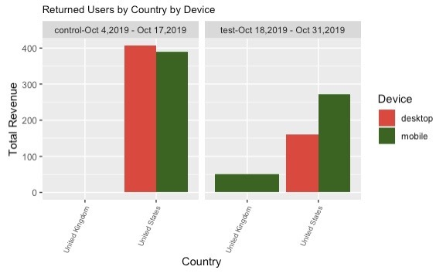

**Figure 4**

**Figure A**

In the dataset regression, the above figures lists the respective countries significant in variation in Revenue for both Users and Returning Users. Mobile device has positive significance for Returning Users in the variations in Revenue.

**#5. Users. Dimensions**: Device, Source **Metrics**: Revenue

**Returning Users. Dimensions**: Device, Source **Metrics**: Revenue

**Figure 5**

The test period dataset when regressed shows the list of Sources significant for variations in Revenue. Device has again no significant role.

**#6. Users. Dimensions**: Channel, Hour **Metrics**: Revenue **Segment** Mobile and Desktop and Tablet, Tablet

**Figure 6**

The Hour- 08:00 am, Transactions and Channel Organic Search has significant effect on variations in Revenue when regressed in data set. Device has no significance.

**#7. Users. Dimensions**: Channel, Age **Metrics**: Revenue  **

**Figure 7**

Age group 45-54, 55-64 and 65+, Users and Transactions are significant in Revenue variation when regressed in the test data set. Device has no significance.

**#8. Users. Dimensions**: Channel, Gender **Metrics**: Revenue  **Segment** Mobile and Desktop and Tablet, Tablet

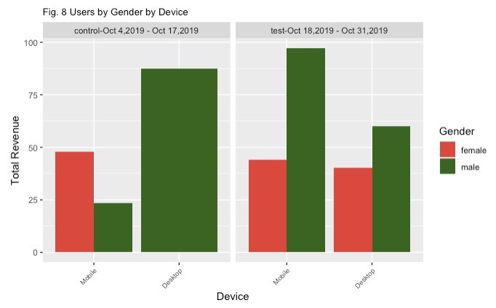

**Figure 8**

Neither Gender nor Device has significance in the variations in Revenue. The dataset has Channel Organic Search and Transactions as significant when regressed.

**INFERENCE**

The Descriptive analysis shows that Mobile is prevalent than Desktop in the test period for various Dimensions.

Device does not seem to be statistically significant when regressed with Dimensions as Age, Gender, Hour, City, Country, Source or Page for Users or Returning Users to determine the variations in Revenue.

For Countries, Mobile Devices are positively significant (Fig. A) in the variations in Revenue for Returning Users.